UNIT II POLYMERS PART - A
1. Write the classification of polymers. (Jan 14, Jan 16)
Classification of Polymers

Origin Thermal response Mode of formation Form and use Tacticity
Natural Thermoplastic Addition Plastic Atactic
Semi-Synthetic Thermosetting Condensation Elastomer Isotatic
Synthetic Fiber Syndiotactic
Liquid resin

2. Define addition polymerization with example. (Nov 16)
Addition polymerization involves addition of monomers to one another to form a long polymer chain without forming any by-product. The polymer product will be the exact multiple of original monomer molecule.
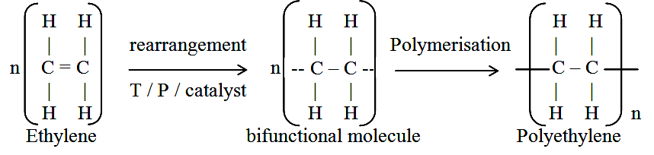
E.g. Polyethylene is produced from ethylene by addition polymerization.

3. Write a note on Co-polymerization with example. (May 18)
It is joint polymerization in which two or more different monomers combine to give polymer.
Copolymerization controls properties such as hardness, rigidity, flexibility and heat resistant nature of polymer. It is mainly carried out to vary properties of polymers over a wide range.
E.g. Butadiene and Styrene copolymerize to give GR-S rubber.
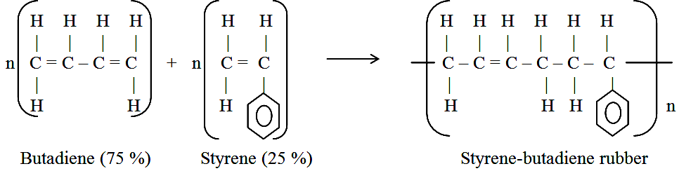

4. What are free radical initiators? Give example. (Jan 14, May 14)
Initiators are the compounds which readily decompose into free radicals so that monomer molecules can interact with these free radicals for their activation.
E.g. Benzoyl peroxide.
5. Write a note on Number average molecular weight. (Nov19)
Number average molecular weight of the whole polymer will be given by,
M_{n} = n₁M₁ / Σn_{i} + n₂M₂ / Σn_{i} + ------ + n_{i}M_{i} / Σn_{i}
M_{n} = Σn_{i}M_{i} / Σn_{i}
Thus it is the total mass of all molecules in a polymer sample divided by total number of molecules present. Number average molecular mass is a good index of physical properties such as impact and tensile strength. It is determined by measurement of osmotic pressure.
6. Calculate degree of polymerization of polypropylene having molecular weight of 84,000 g/mol. (Jan 15)
Molecular weight of polymer (Mw)
Degree of polymerization (Dp) =
Molecular weight of monomer (M)
Dp = 84,000 / 42.08 = 1996
7. Calculate number average molecular weight of polyethylene which has 50 molecules of molecular weight 75,000 and 100 molecules with 1,00,000 and 25 molecules with 50,000. (Jan 14, May 16)
M_{n} = n₁M₁ / Σn_{i} + n₂M₂ / Σn_{i} + ------ + n_{i}M_{i} / Σn_{i}
M_{n} = Σn_{i}M_{i} / Σn_{i}
= {(50x75,000)/75,000} + {(100x1,00,000)/1,00,000} + {(25x50,000) / 50,000} = 175
8. Differentiate thermoplastics and thermosetting plastics. (Jan 14, May 16, Nov 18, Nov 19, Sep 20)
Thermoplastics resins | Thermosetting resins
(i) Obtained by addition polymerization.  (ii) Consist of linear long chain with low molecular weights.  (iii) Weak, soft and less brittle.  (iv) Soften on heating and harden on cooling in the mould.  E.g. Polyethylene, polystyrene, PVC, PTFE, Nylons, etc. | Obtained by condensation polymerization.  3 dimensional network structures with high molecular weights.  Strong, hard and more brittle.  Do not soften on heating in the mould.  E.g. Bakelite, urea formaldehyde, silicones, polyesters, etc.
9. Give the preparation and uses of Poly Vinyl Chloride (PVC). (May 18)
PVC is produced by emulsion polymerization method. It is prepared by heating a water emulsion of vinyl chloride in presence of a small amount of benzoyl peroxide or hydrogen peroxide in an autoclave under pressure.
Vinyl chloride so-needed is prepared by treating acetylene with hydrogen chloride at 80° C, in presence of metal chloride as catalyst.
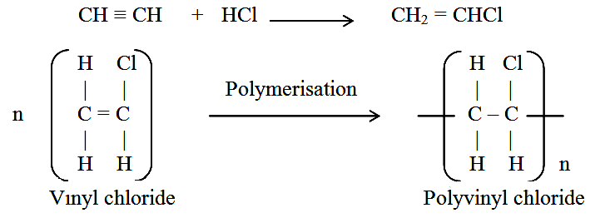

Uses: PVC is used with or without plasticizer.
- Plasticized PVC is used for making rain coats, table cloths, toys, handles, etc.
- Rigid PVC is used for making helmets, refrigerator components, tank linings, tube for use in place non-ferrous metals.
10. Why the TEFLON is chemically resistant? (May 15)
Due to presence of highly electronegative fluorine atoms and regular configuration of polytetrafluoro ethylene molecule results in strong attractive forces between different chains.
Strong forces give extreme toughness, high softening point. Hence, Teflon has exceptionally high chemical resistance towards all chemicals.
11. Give the preparation and uses of Polyurethane. (Jan 15, May 15, Nov 19)
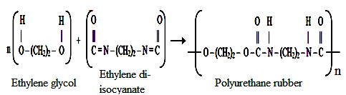
Polurethane rubber (isocyanate rubber) is produced by reacting polyalcohol with di-isocyanates.
Uses
For surface coating and manufacture of foams and spandex fibres.
12. What are the drawbacks of raw rubber? (May 17)
- Raw rubber is plastic in nature and becomes soft at high temperature and brittle at low temperature. So it can be used in the temperature range of 10 to 60º C only.
- It is weak and has large water–absorption capacity.
- When stretched to a great extent, it suffers permanent deformation, because of sliding/slippage of some molecular chains over each other.
13. Write a note on Vulcanization. (May 14, May 15, May 19)
To improve the properties of rubber, it is compounded with sulphur and the process consists in heating raw rubber with sulphur to 100-140º C. The added sulphur combines chemically at the double bonds of different rubber springs. Vulcanization thus serves to stiffen the material.
For example a tyre rubber may contain 5% sulphur, but a battery case rubber may contain 30% sulphur.
14. Give the preparation and uses of Styrene rubber. (Nov 17)
Styrene rubber is probably the most important type of synthetic rubber, which is produced by copolymerization of butadiene (75% by weight) and styrene (25% by weight).

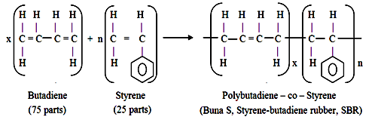

Uses
Styrene rubber mainly used for manufacture of motor tyres. Other uses of this elastomer are floor tiles, gaskets, foot-wear components, wire and cable insulations, carpet backing, adhesives, tank-lining, etc.
15. Give the preparation and uses of Nitrile rubber. (Nov 18)
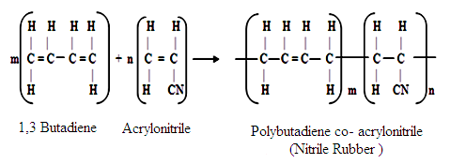
Nitrile or Buna-N rubber is a copolymer of butadiene and acrylonitrile.

Uses
For making conveyor belts, high altitude aircraft components, tank-lining, hoses, gaskets, printing rollers, adhesives, oil resistant foams and automobile parts, etc.
16. Write note on Laminar composites. (Jan 16)
Laminate is a product obtained by joining two or more layers of solid materials. If grains of the laminates are parallel to each other, it is called parallel laminate and if grains are arranged at right angles to others, it is called cross-laminate.
Some important laminates are, Plywood (wood laminate), Laminated plastics, Laminated Glass, Thermocole.
17. Give the types and applications of Conducting polymer. (May 15, Jan 15, Nov 16)
Applications of conducting polymers:
In rechargeable light weight batteries and in optically display devices.
- Wiring in aircrafts, aerospace components and communications.
- In coatings for clothing and in electromagnetic screening materials.

18. Virgin rubber is used as pure gold. Give reason. (May 17)
Raw rubber is like pure gold, since it forms the basic material for manufacturing various valuable items like tyres, tubes, hoses adhesives, sponge, foam-rubber, golf balls, printing rollers, etc. However, natural rubber is useless as such, since it possesses poor characteristic (like high elasticity, poor chemical resistance, solubility in organic solvents, etc).

19. Give one example each for a compound having functionality two and three respectively. (May 17)
The number of bonding sites in a monomer is referred as its functionality.
Ex: COOH-CH₂-COOH Functionality 2
COOH-CH₂-CH-CH₂-COOH Functionality 3

20. Why Bakelite cannot be remoulded? (Nov 17)
Bakelite is formed by condensation polymerisation which is thermosetting plastic. The bonding is covalent and hence Bakelite cannot be remoulded.

PART – B
1. Explain classification of polymers based on their Tacticity. (May19)
Polymers can have different chemical structures, physical properties, mechanical behavior, thermal characteristics, etc. and can be classified in different ways.
Tacticity
- Isotactic: Functional groups are arranged in same side of chain.
- Atactic: Functional groups are at random around main chain.
- Syndiotactic: Functional groups are arranged in alternate fashion around main chain.
E.g. Polypropylene.
2. Explain various types of polymerization. (Nov 10, May 11, May 15)
There are mainly three kinds of polymerization.
(a) Addition or Chain polymerization
Addition polymerization involves addition of monomers to one another to form a long polymer chain without forming any by-product. Polymer product will be the exact multiple of original monomer molecule.
Original monomeric molecule usually contains one or more double bonds. Reaction must be initiated by application of heat, light, pressure or catalyst. Double bond of monomer is broken and an unstable, excited bifunctional species is produced. Monomers add on side of this species to form a linear polymer chain. It generally produces thermoplastic polymers.
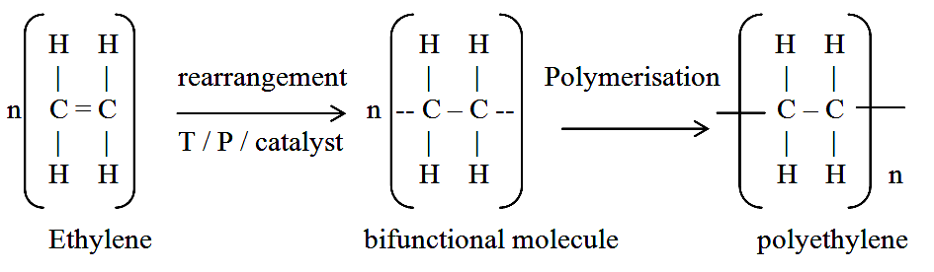
This polymerization is also called as chain polymerization because self-addition of monomer molecules takes place very rapidly through a chain reaction. In this addition polymerization there is no byproduct.

E.g. Polyethylene is produced from ethylene by addition polymerization.
(b) Condensation or Step polymerization (May 15)
A reaction occurring between simple polar group containing monomers such as hydroxyl, carbonyl, amino groups with the formation of polymer and elimination of small molecules like water, HCI, etc. is called condensation polymerization. This polymerization occurs, only if monomers contain at least two reactive functional groups. These reactive centers may be same or different.
E.g. Hexamethylene diamine and adipic acid condense to form Nylon 6:6.
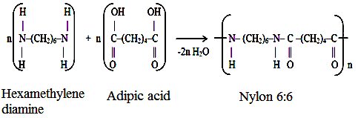
Thus, it is an intermolecular combination and it takes place through different functional groups having affinity for each other. When monomer contain three functional groups, it may give a cross linked polymer.

In some cases, it takes place without elimination of small molecules. e.g. polymerisation of Caprolactum to produce Nylon 6.
(c) Copolymerization
It is the joint polymerization in which two or more different monomers combine to give a polymer. Copolymerization controls properties such as hardness, rigidity, flexibility and heat resistant nature of polymer. It is mainly carried out to vary the properties of polymers over a wide range.
E.g. Butadiene and Styrene copolymerize to give GR-S rubber.
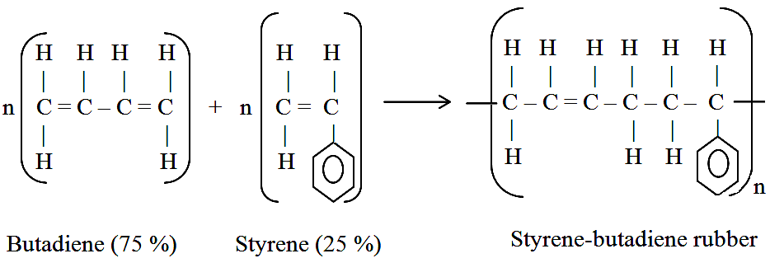

3. Explain Free - Radical polymerization mechanism. (Jan 11, May 12, May 13, Jan 15, Nov 16, May 17, Nov 18)
It consists of three major steps, namely initiation, propagation and termination. The initiation of polymer chain growth is brought about by free radicals produced by the decomposition of compounds called initiators.
The term chain growth represents a process involving a continuous and very rapid addition of monomer units to form polymer molecules or chains. As more and more monomer units are added, length of the polymer chain increases continuously and the chain grows rapidly.
Initiation
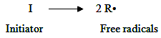
First step is the production of free radicals, usually by homolytic dissociation of an initiator to yield a pair of radicals R•.

Second step involves the addition of this radical to first monomer molecule to produce the chain initiating species.
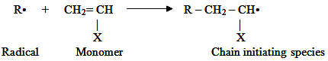

Propagation
This step consists of growth of chain initiating species by successive additions of large numbers of monomer molecules.
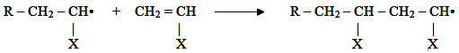

Termination
At some point, the propagating polymer chain stops growing and terminates. This termination may be,
- coupling or combination
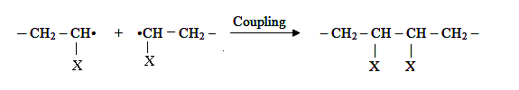

or (ii) rarely by disproportionation
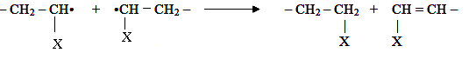

4. Write the mechanism of Cationic polymerization. (Jan 14, May 15, Nov 19)
In a polymerization when initiation is done by a proton and propagation is carried out by a carbonium ion, is called “Cationic polymerization”. The ionic mechanism of chain polymerization also involves attack on π- electron pair of the monomer. Examples of that can undergo cationic polymerization are isobutylene, styrene and vinyl ethers.
Initiation
When a proton is introduced into a system, it pulls the π electron pair towards it. The positive charge of proton is transferred to farther end of monomer molecule, forming a carbonium ion. The sigma bond is formed between proton and monomer unit and the polymer chain growth “initiated”. The initiators used are BF₃, SnCl₃ and TiCl₄.
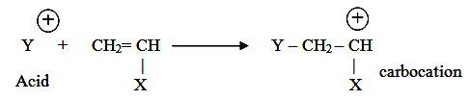

Propagation
The carbonium ion (C⁺) attacks π electron pair of second monomer molecule and pulls it over. The positive charge is transferred to farther end of second monomer unit and thus a chain reaction sets in. As more monomer units are added up, chain keeps on growing.
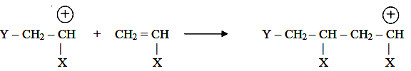

Termination
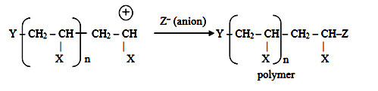
It occurs when collision between growing C⁺ ion and anion takes place.

Possible reactions that take place during termination are,
- Donation of a proton to the counter-ion, resulting in the formation of a double bond at the end of the growing polymer molecule and the resultant arrest of chain growth.
- Formation of a covalent bond between the carbonium ion and the counter-ion when termination occurs by coupling.
5. Write note on Anionic polymerization. (May 16, May 19, Nov 19)
There is another type of ionic polymerization, called “anionic polymerization”, where the attack on π electron pair of monomer is done by a negatively charged ion, an anion.
Monomers capable of undergoing anionic polymerization include butadiene, isoprene, styrene and acrylonitrile.
Initiation
When the system has extra electrons, the negative charge of this attacks π electron pair, pushing it, as far away as possible, to the end of molecule.
At the same time, it forms a sigma bond with monomer molecule. The electron pair pushed to the end of molecule results in the formation of a carbanion. The initiators used are butyl lithium, triphenyl methyl potassium and ethyl sodium.
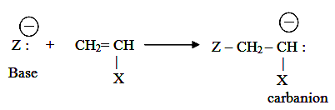

Propagation
By attacking second monomer unit, pushing its π electron pair further away to the end and forming a sigma bond with new monomer unit.
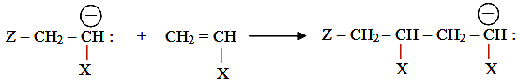

Termination
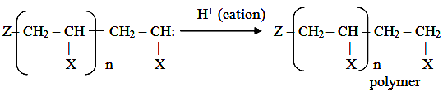
Termination in anionic polymerization is not usually spontaneous process, and unless some impurities are present or some strongly ionic substance are added deliberately, like a cation, no termination occurs.

Thus if polymerization is carried out under controlled condition and impurities are avoided, the reaction proceeds till all monomer is consumed.
In this case, while there is no more monomer left to be polymerized, carbanions at the chain end remain potentially active. The difference between cationic and anionic processes is that, in former case, movement of electron pair is in a direction opposite to that of the chain growth, whereas in latter case, it is in same direction as that of chain growth.
6. What is the mechanism involved in Coordination or Ziegler-Natta polymerization? (May 12, Jan 13, May 15, Jan 16, May 16, Nov 17, Sep 20)
These are special type of coordination catalysts comprising two components as catalyst and co-catalyst. The catalyst component consists of halides of IV-VIII group elements having transition metal valence electrons and the co-catalysts are organo-metallic compounds.
Most commonly used catalyst is based on the organo-aluminium compounds such as triethyl aluminium (AlEt₃) in combination with titanium chloride (TiCl₃). Aluminum alkyls act as electron acceptor and electron donor is titanium halides and the combination, therefore, readily form coordination complexes.
Initiation
When catalyst and co-catalyst components are mixed, there occur chemisorptions of aluminium alkyl on titanium chloride solid surface, resulting in formation of an electron-deficient bridge complex.
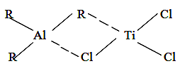

Cat – Z Cat – Z

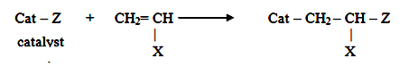
This complex now acts as the active centre. The monomer is then attracted towards Ti–C bond in the active centre.

Propagation
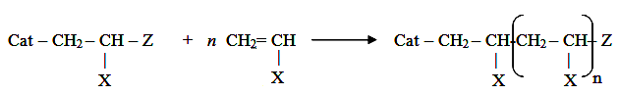
With addition of a second monomer molecule, the monomer insertion is repeated and the orientation of substituent group of monomer is always taken from the metal-ion, resulting in a stereo-regulated polymer.

Termination
Termination of polymer takes place by addition of active hydrogen compound with regeneration of catalyst.
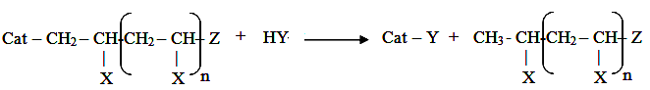

Application
Ziegler-Natta polymerization is used to prepare polypropylene, polyethylene, polydiene, etc. The importance of this method lies in the fact that stereospecific polymers are obtained.
Thus during polymerization of propylene, using conventional catalysts, normally random or atactic polymer is obtained. By using suitable catalyst, solvent and temperature, it is possible to produce desired type like atactic or syndiotactic of stereoisomer. The atactic polymers are soft and elastic; while the other two are dense.
7. Explain chemical resistance, crystallinity and effect of heat on polymers. (May 14, Jan 15, Jan 16)
(i) Chemical Resistance
Chemical nature of monomeric units and their molecular arrangement determines the chemical resistance of polymers. Usually the attack is internal, causing softening, swelling and loss of strength of material. As a general rule, like materials attract; unlike materials repel. Thus a polymer is more soluble in structurally similar solvent.
For eg, polymers containing polar group like –OH and –COOH are usually swollen or dissolved in polar solvents like water, alcohol, ketones, but they are nearly chemically-resistance to non-polar solvents like benzene, toluene, petrol and CCl₄.
On the other hand, polymers having non-polar groups such as methyl, phenyl are swollen or dissolved in non-polar solvents such as benzene, toluene, petrol, etc. But they are resistant to polar solvents. Moreover polymers of more aliphatic character are more soluble in aliphatic solvents; whereas those of aromatic character are more soluble in aromatic solvents.
(ii) Crystallinity of polymer
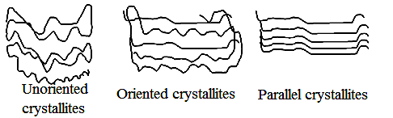
Degree to which molecules of a polymer are arranged in orderly pattern with respect to each other is a measure of crystallinity. Longer molecules have more geometrical opportunities for partially crystalline arrangements than shorter ones. The example is given to illustrate that there is less sharp distinction between ‘crystalline’ and ‘non-crystalline’ for macromolecular material than substance of low molecular mass.

A small region of a macromolecular material in which portions of large molecule are linked to each other in some regular way, is called crystallite. It is the orderly orientation of crystallites with respect to each other that builds up crystallinity in a polymer.
In fibrous polymeric structures, small aggregated crystallites, just large enough to appear as a small thread–like unit under a high power microscope, are called fibrils.
(iii) Effect of heat on polymers (Jan 14)
Amorphous polymers do not possess melting point but possess only softening point. At low temperatures, polymers exist as glassy materials.
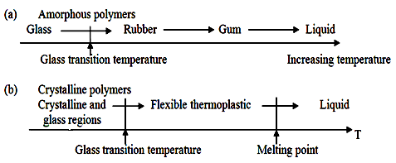
In this state, solid tends to shatter if it is hit, because molecular chains cannot move at all easily. If polymer is heated, it eventually softens and becomes more flexible. This happens at glass transition temperature (Tg).

After this, crystalline and amorphous thermoplastic polymers behave differently. Heating has little effect on thermosetting polymers, until at high temperature, they are destroyed. Softening indicates that polymer chains have gained energy to move slightly (e.g. twisting).
The softened polymer does not shatter, because energy of blow on polymer gets dispersed by the chains moving violently and passing on the energy along and across chains. A polymer that has the ability to flex and twist of its chains is called an elastomer. Thus the amorphous polymers do not posses any clear melting point.
8. Discuss types of determining molecular weight of polymers. (Nov 10, May 18, Nov 19)
Molecular weight of polymer can vary from single digit figure for a simple species to number in millions for a complex polymer. Polymers are polydisperse and quite heterogeneous in molecular mass and comprises molecules of different molecular weights. Hence, molecular mass of a polymer is quite different from small sized compounds and its molecular weight is expressed in terms of average value.
Following are the main types of determining molecular mass of polymer.
(i) Number–Average molecular mass (M_{n})
It is determined by measurement of osmotic pressure.
Assume that there are n numbers of molecules in a polymer sample and n₁ of them have M₁ molecular weight: n₂ have M₂ molecular weight and so on till n_{i} having M_{i} molecular weight.
Now total number of molecules (n) given by,
n = n₁ + n₂ + ----- + n_{i} = Σn_{i}
Number of molecules in fraction 1 = n₁
Number fraction of fraction 1 = n₁ / n
= n₁ / Σn_{i}
Molecular weight contribution by fraction 1 = n₁M₁ / Σn_{i}
Number average molecular weight of the whole polymer will be given by,
M_{n} = n₁M₁ / Σn_{i} + n₂M₂ / Σn_{i} + ------ + n_{i}M_{i} / Σn_{i}
M_{n} = Σn_{i}M_{i} / Σn_{i}
Thus, it is the total mass of all molecules in a polymer sample divided by total number of molecules present. The number average molecular mass is a good index of physical properties such as impact and tensile strength.
(ii) Weight-Average Molecular mass (M_{w})
It is obtained from light scattering method.
Total weight of the polymer w = Σn_{i}M_{i}
Weight of fraction 1 = w₁ = n₁M₁
Weight fraction of fraction 1 = n₁M₁ / w
= n₁M₁ / Σn_{i}M_{i}
Molecular weight contribution by fraction 1 is given by,
n₁M₁.M₁ / Σn_{i}M_{i} = n₁M₁² / Σn_{i}M_{i}
Weight average molecular weight of the whole polymer will be,
M _{w} = n₁M₁² / Σn_{i}M_{i} + n₂M₂² / Σn_{i}M_{i} + ------ + n_{i}M_{i}² / Σn_{i}M_{i}
M _{w} = Σn_{i}M_{i}² / Σn_{i}M_{i}
For all synthetic polymers, weight average molecular mass is greater than number average molecular mass. If they were to be equal, the polymer sample may be considered that each molecule has same molecular weight, but this does not happen. So the ratio M_{w} / M_{n} may be used as an index of polydispersity.
9. Differentiate between thermoplastics and thermosetting plastics.
(Nov 10, Jan 11, May 11, May 12, Jan 13, May 14, May 15, May 17)

Thermoplastics resins | Thermosetting resins
(i) They are formed by addition polymerization.  (ii) They consist of linear long chain polymers with low molecular weights.  (iii) All polymer chains are held together by vanderwaals forces.  (iv) They are weak, soft and less brittle.  (v) They soften on heating and harden on cooling in the mould.  (vi) They are fusible and can be remoulded.  (vii) They are soluble in organic solvents.  E.g. Polyethylene, polystyrene, PVC, PTFE, Nylons, etc. | They are formed by condensation polymerization.  They consist of three dimensional network structures with high molecular weights.  All polymer chains are linked by strong covalent bonds.  They are strong, hard and more brittle.  They do not soften on heating in the mould.  They are not fusible, cannot be remoulded.  They are insoluble in organic solvents.  E.g. Bakelite, urea formaldehyde, silicones, polyesters, etc.
10. Explain preparation, property, uses of Polyvinyl chloride. (Nov 10, Jan 11, May 15, May 19)
Preparation
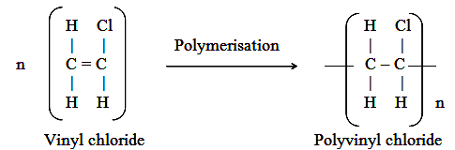

PVC is produced by emulsion polymerization method. It is prepared by heating a water emulsion of vinyl chloride in presence of a small amount of benzoyl peroxide or hydrogen peroxide in an autoclave under pressure.
Vinyl chloride so-needed is prepared by treating acetylene with hydrogen chloride at 80°C, in presence of metal chloride as catalyst.
CH ≡ CH + HCl CH₂ = CHCl
Properties
(i) It is colourless, odourless, inflammable and chemically inert powder.
(ii) It is resistant to light, oxygen, inorganic acids, alkalis, soluble in hot ethyl chloride.
(iii) It poses high softening point, greater stiffness and rigidity.
Application
PVC is used with or without plasticizer. Thus, there are two kinds of PVC.
(a) Plasticized PVC: It is produced by mixing plasticizers like dibutyl phthalate, tricrysyl phosphate, etc., with PVC resin uniformly.
Uses (i) For making rain-coats, table-cloths and curtains.
(ii) For injection moulding articles like toys, tool-handles, toilet articles, radio and T.V components.
(iii) For making chemical containers, thermal insulating foam, conveyor belts, etc.
(b) Rigid PVC: Rigid PVC or unplasticized PVC has high chemical resistance and high rigidly, but is brittle.
Uses (i) For making sheets, which are used for tank-linings and light fitting.
(ii) For making safety helmets, refrigerator components, tyres, cycle and motorcycle mudguards, trays, etc.
(iii) It is used in the form of strip and tube for use in place of non-ferrous metals.
11. Give preparation, property, uses of Teflon.(Jan 11, May 13, Jan 15, May 15, Nov 17)
TEFLON (PTFE or Polytetrafluoroethylene or FLUON)
Preparation
Teflon is obtained by polymerization of water–emulsion of tetrafluoro ethylene under pressure in presence of benzoyl peroxide as catalyst.
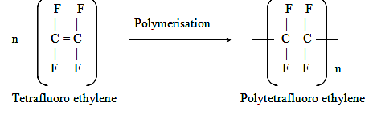

The monomer, tetrafluoro ethylene can be prepared from chloroform and hydrochloric acid which reacts together to form difluoro monochloro methane and then tetrafluoroethylene.
CHCl₃ + HF CHF₂Cl CF₂ = CF₂
Properties
(i) Presence of high electronegative fluorine atoms and regular configuration of polytetrafluoro ethylene molecule results in strong attractive forces between different chains.
(ii) Strong forces give extreme toughness, high softening point, exceptionally high chemical resistance towards all chemicals.
- It has high density, waxy touch, very low coefficient of friction, extremely good electrical and mechanical properties.
(iv) It can be machined, punched and drilled.
Uses
(i) As insulating material for motors, transformers, cables and wires.
(ii) For making gaskets, packing, pump parts, tank linings, chemical-carrying pipes, tubing, etc.
(iii) For coating and impregnating glass fibres, asbestos fibres, cloths and in non-lubricating bearings and non-sticking stop-cocks for burettes.
(iv) As non–stick coating for pots and pans.
12. Write the preparation, properties and uses of Nylons. (May 15, Nov 18, May19, Nov19)
Preparation
Nylon 6:6 is obtained by condensation polymerization of hexamethylene diamine with adipic acid. Nylon 6:6 derives its name from its starting materials both of which have six carbons.

Properties
(i) Nylon is tough, strong and easily mouldable, translucent and high melting polymers.
(ii) It has high temperature stability, good abrasion-resistance and self lubrication.
(iii) They are insoluble in common solvents but soluble in phenol.
(iv) They are very flexible and retain original shape after use.
Uses
- Nylon-6:6 is primarily used for fibres, which find use in making socks, under-
garments, dresses, carpets, etc.
(ii) For making filaments for ropes, bristles for tooth brush, etc.
(iii) As a good substitute for metal in gears and bearings.
- In making tyres, watch straps, etc.

Nylon 6 (Nov 10, May 11)
Nylon-6 is produced by self condensation of ε-amino caproic acid.
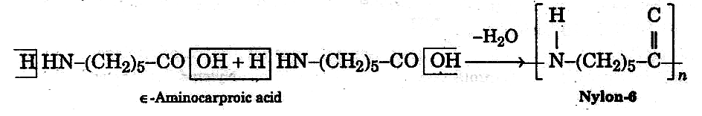
Uses
Nylon-6 is used for moulding purposes for gears, bearings, electrical mountings, etc.

Nylon 11
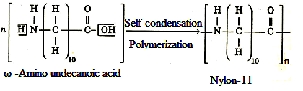
It is obtained by self condensation polymerization of ω-amino undecanoic acid.

Uses
As a good substitute for metal in gears and bearings and in making tyres and watch straps.
13. Discuss the preparation, properties and uses of Bakelite. (May 10, Jan 13, Jan 14, May 14, Jan 16, May 16, Nov 16, Sep 20)
Preparation
Bakelite is obtained by condensation polymerization of phenol and formaldehyde in presence of acid or base catalyst. Nature of product depends on the proportions of reactants and nature of catalyst.
Acid catalysts used are HCl, H₂SO₄, tartaric acid, formic acid, etc. Basic catalysts used are sodium carbonate, lime, etc.
Steps involved in preparation of Bakelite are,
Step 1 – Formation of Methylol derivatives
Initial reaction between phenol and formaldehyde results in the formation of addition compounds of ortho and para hydroxy methyl phenol called methylol derivatives. They may be considered as the monomer for further polymerization.
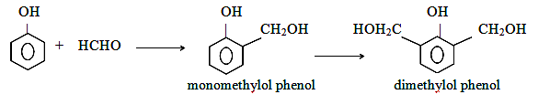

Step 2 – Novolac formation
In presence of acid catalyst with excess of phenol, methylol derivatives condense with phenol to form dihydroxy diphenyl methane. Further condensation leads to the formation of linear low polymers called Novolac.
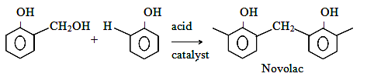

Step 3 – Resol formation
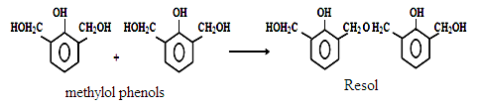
In presence of alkaline catalyst and excess of formaldehyde, methylol phenols may condense either through methylene linkage or through ether linkage to form Resol.

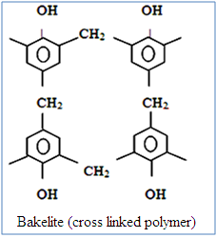
Step 4 – Bakelite production
Further, heating of novolac or resol or both in presence of a curing agent like hexamethylene tetramine, produces excessive cross links. The final product is hard, rigid, infusible and insoluble solid called Bakelite.

Properties
(i) Bakelite resins are resistant to acids, salts and most organic solvents.
(ii) It is rigid, hard, scratch resistant, infusible and insoluble solid.
(iii) They are water resistance and possess excellent electrical insulation.
Uses
(i) For making moulded articles like telephone parts, cabinets for radio and television.
(ii) For making electrical insulator parts like plugs, switches, boards and heater handles.
(iii) For impregnating fabrics, wood and paper.
(iv) As adhesives for grinding wheels and used in paints and varnishes.
(v) As hydrogen exchanger resins in water softening process.
(vi) For making bearings, used in propeller shafts for paper mills.
14. Write the preparation, properties and uses of Polyurethane. (May 13, May 14, May 16, May 17, Sep 20)
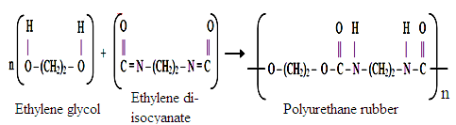
Preparation

Polurethene rubber (or isocyanate rubber) is produced by reacting polyalcohol with di-isocyanates.
Properties
- Polurethanes are highly resistant to oxidation, because of their saturated character.
- They also show good resistance to many organic solvents, but are attacked by acids
and alkalis, especially concentrated and hot.
- They are light, tough and resistant to heat and chemicals.
Uses
For surface coating and manufacture of foams and spandex fibres.

15. Explain Vulcanization process and its advantages. (Nov 11, May 11, May 12, May 14, Nov 16, Nov 17, May 18, Nov 19, Sep 20)
To improve the properties of rubber, it is compounded with some chemicals like sulphur. The process consists in heating the raw rubber with sulphur to 100-140 ºC. The added sulphur combines chemically at double bonds of different rubber springs. Vulcanization thus serves to stiffen the material by a sort of anchoring and consequently preventing intermolecular movement of rubber springs.
Extent of stiffness of vulcanization rubber depends on the amount of sulphur added. For example, tyre rubber contain 5% sulphur, but battery case rubber may contain 30% sulphur.
Vulcanization of raw rubber with sulphur acts as vulcanizing agent. Vulcanite or abonite or hard rubber contains about 32% sulphur. The cross-linking of isoprene spiral is attained to such an extent that vulcanite has practically no elasticity. It can be drilled and polished. It has extremely good electrical insulation properties.
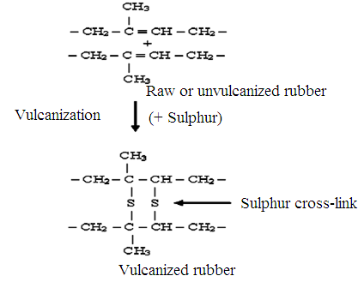

Advantages of vulcanization and vulcanized rubber
- Has good tensile strength and extensibility when a tensile force is applied, can bear a load of a 2,000 kg/cm² before it break.
- Has excellent resilience, i.e. article made from it returns to original shape when the deforming load is removed.
- Possesses low water-absorption tendency and higher resistance to oxidation and to abrasion and has low elasticity.
- Has much higher resistance to wear and tear compared to raw rubber.
- Has better electrical insulator, although it tends to absorb small amounts of water. Ebonite is better insulator.
- It is resistant to organic solvents (such as petrol, benzene carbon tetrachloride), fats and oils.
- Easy to manipulate vulcanized rubber to produce the desired shapes.
- Has useful temperature range of -40 to 100 ºC and has only slight tackiness.
16. Discuss the preparation, properties and uses of Styrene rubber (GRS or Buna-S). (Jan 11, May 11, Nov 11, May 13, May 17, Nov 19)
Styrene rubber is probably the most important type of synthetic rubber, which is produced by copolymerization of butadiene (75% by weight) and styrene (25% by weight).
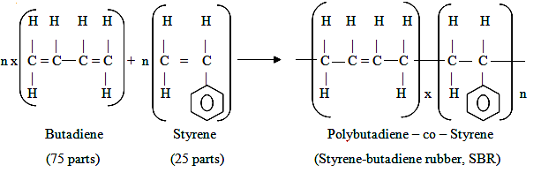

Properties
- Styrene rubber resembles natural rubber in processing as well as quality of finished products. It possesses high abrasion-resistance, high load-bearing capacity and it swells in oil and solvents.
- It can be vulcanized in same way as natural rubber either by sulphur or sulphur monochloride. However it requires less sulphur, but more accelerators for vulcanization.
Uses
- Mainly used for the manufacture of motor tyres.
- Other uses are floor, tiles shoe soles, gaskets, foot-wear components, wire and cable
insulations, adhesives and tank-lining.
17. Explain the preparation, properties and uses of Nitrile rubber (GRX or Buna N). (Nov 19)
Nitrile or Buna-N rubber is a copolymer of butadiene and acrylonitrile.

Properties
- It possesses excellent resistance to heat, sunlight, oils, acids and salts, but it is less resistant to alkalis than natural rubber, because of presence cyano groups (– CN).
- As proportion of acrylonitrile is increased, resistance to acids, salts, oils, solvents, etc increase but the low-temperature resilience suffers.
- Vulcanized nitrile rubber is more resistant to heat and ageing than natural rubber and may be exposed to high temperatures.
Uses
- For making conveyor belts, aircraft components and tank-lining.
- It is also used to make hoses, gaskets, printing rollers, adhesives, oil resistant foams
and automobile parts.
18. Write preparation, properties and uses of Butyl rubber. (May 14)
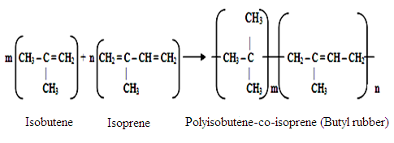
Butyl rubber is made by copolymerization of isobutene with isoprene.

Properties
- It possesses outstanding low permeability at air and other gas.
- It has excellent resistance to heat, abrasion, ageing, chemicals, polar solvents, but is soluble in hydrocarbon solvents like benzene.
- It has high resistance to ozone and has good electrical insulating properties, it can be vulcanized, but cannot be hardened much, due to very low unsaturation.
Uses
- It is used for making cycle and automobile tubes, automobile parts, hoses, conveyor
belts for food and other materials.
- It is also used for making tanks-linings, insulation for high voltage wires and cables.
19. Write note on Silicone rubbers. (May 18)
Silicone resins contain alternate silicon-oxygen structure, which has organic radicals attached to silicon atoms.
Preparation
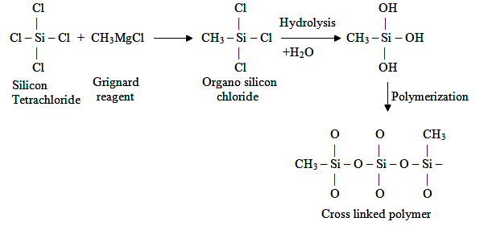

Silicone rubber is produced by reacting silicon with alkyl halide or silicon halide with Grignard reagent. The reaction product is fractionally distilled to get different organo-silicon chlorides, which are then polymerized by carefully controlled hydrolysis.
Silicone rubbers are obtained by mixing high molecular weight linear dimethyl silicone polymers with fillers like silicone dioxide and peroxide having curing agents. Peroxide causes formation of dimethyl bridge between methyl groups of adjacent chains.
Vulcanization of silicone rubber
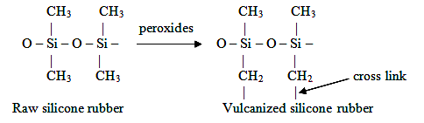
Properties
- They possesses resistance to prolonged exposure to sun light, weathering, oils, boiling water, dilute acids and alkalis.
- They remain flexible in the temperature range of 90-250º C.
Uses
- As sealing materials in aircrafts engine and search lights, as adhesive in electronic
industry and insulation for washing machines.
- For insulating electrical wiring in ships. Used in making lubricants, paints and
protective coatings for fabric finishing and water proofing.
- For making artificial heart valves, transfusion tubings and padding for plastic surgery.

20. Explain Fibre Reinforced Plastics (FRP) and its application. (May 15)
Combination of polymeric substance with solid fillers is called filled or reinforced plastics. The filler acts as reinforcing material; while polymer acts as binder, which links the filler particles. The polymer serves as stress transforming agent from filler to filler particles.
Characteristics
Polymers generally of low strengths and moduli of elasticity are needed for structural purposes. For these reasons, the polymers are combined with fillers to get better products. Fillers modify the physical properties, particularly the mechanical properties of basic polymeric materials.
For example, they improve thermal stability, mechanical strength, insulating characteristics, water resistance, appearance, rigidity, finish, hardness, opacity and workability; beside reducing cost, shrinkage on setting and brittleness. Usually, specific fillers are added to a polymeric compound to impart special characters to the final product. They possess good thermal and shock resistance, good dimensional stability, good process ability and moulded articles can be repaired easily.

Examples for Fillers
Most commonly used fillers are wood-flour, saw dust, ground cork, asbestos, marble flour, china clay, paper pulp, corn husk, mica, carbon, cotton fibres, silicon carbide, silicon nitride, graphite, alumina, glass fibres, cotton fibres, metallic oxides like ZnO, PbO etc., and metallic powder like Al, Cu, Pb, etc. Fillers are usually employed in sizable weight percentage and it can be up to 50% of total moulding mix.
Nature of polymers used
Polymers used are thermoplastics, thermosetting polymers as well as rubbers such as polyethylene, polypropylene, Nylon-6, PET, polystyrene, melamine, silicone, natural and synthetic rubbers, epoxy resins, etc.
Examples of filled plastics
- Carbon black on addition to natural rubber brings about 40% increase in tensile
strength and used in automobile tyres.
(ii) Addition of china clay to PVC enhances insulation character.
(iii) PVC and calcium carbonate combination is used for general purposes like tubings, seat covers, wires and cable insulations.
(iv) Fibrous fillers like wood flour, short lengths of synthetic fibres, cotton floc, macerated paper and cloth are used in thermosetting polymers to get filled plastics of higher impact strength.
(v) Asbestos filled plastics are employed in electrical appliances.
Applications of filled plastics
(i) In automobiles for making door handles, battery cases and engine cooling fans.
(ii) In defense for making nose cones, pistol grips and riffle bullets.
(iii) In textile for making shuttle.
(iv) In electrical and electronic industry for making exhaust fan, computer tape, insulators, wire and cable insulation, gear parts, etc.
(v) In consumer goods like door, window, chair and camera housing.
(vi) Miscellaneous materials like water meter housings, chemical pump housings, tubings, seat coverings, etc.
21. Write a note on laminar composites. (Jan 15, May 17, Nov18, Nov 19)
Laminate is a product obtained by joining two or more layers of solid materials. If the grains of laminates are parallel to each other, it is called parallel laminate and if the grains are arranged at right angles to others, it is called cross-laminate. The layers of materials so bonded, by an adhesive, are called adherends. Thus the combination of an adhesive and adherends is a laminate. Some important laminates are,
- Plywood (wood laminate)
It is obtained by bonding together an odd number of veneers (thin sheets of wood 0.5 to 10 mm thick) in such a way that grains of alternate veneer are at right angles to each other. Thus, plywood is a cross-laminate and this makes the properties of product almost along its length and width.
Plywood for interior use is bonded with resin glue or protein glue and it may be pressed hot or cold. On the other hand, plywood for exterior use is bonded with phenolic resin by hot pressing, since it should be water proof.
Uses
For cabinet making, aircraft and railway coach building, and house building purposes like flush-doors, cup-boards and false-ceiling.
- Laminated plastics
They are obtained by impregnating sheets of wood, paper, cloth, and asbestos fibres, glass, metal foil, nylon, etc. with a resin solution. Thermosetting resins like urea formaldehyde, phenol formaldehyde are commonly employed for this purpose.
The paper, cloth, linen, canvas, silk, etc., in roll form, is passed through a solution of resin and dried at a temperature much lower than curing temperature of resin. The sheets are then cut in suitable size and piled one over other.
They are then subjected to curing in a hydraulic press at about 180°C under a pressure of 120 kg/cm², when resin becomes hard and bonds the sheets into compact material.
Properties
Laminated plastics are light and strong, machinable, impermeable to water and oils, resistance to acids, alkalis and has high dielectric constant. However, complicated shapes cannot be obtained, unlike plastic moulding.
Uses
They are extensively used for electrification, insulation, making silent gears, water lubricated bearings, pulley wheels, pump parts and press tools. They are also used for decorative purposes in wall paneling, translucent paneling, table counter tops and as base for making printing blocks.
- Laminated Glass
Laminated Glass is obtained by joining glass plates/sheets with a layer of plastic in between them. By lamination, strength of glass is enhanced. For transparent glass laminates, adhesive used is polyvinylbutyl resin.
Safety glass is a kind of laminated glass obtained by fixing a dry sheet of plastic between two glass sheets, using moderate heat. Then, it is cured by heating in an oven and subjecting simultaneously to pressure. Such a glass is splinter-proof and shock-absorbent.
On receiving a sudden impact, it does not shatter to pieces. Bullet-proof glass is similarly obtained by joining together several sheets of glass.
Uses
Safety glass is used in making wind shields for cockpits of aircraft and in automobiles..
- Thermocole
It is foamed plastic, obtained by blowing air/gas through molten polystyrene or polyurethane.

Properties
It is quite strong, yet extremely light. Its density is about 20 kg/m³. Thermal and electrical conductivity are quite low. It resists aging, chemically inert and quite shock proof. It is used up to 55° C. It is so soft that it can be easily cut by a knife and can be scratched by nail.
Uses
Thermocole is used as thermal insulating material in refrigeration and air conditioning, buildings, theaters, auditorium, cold storages, etc. Thermocole slabs are used for ceilings and wall linings of air-conditioned and acoustic buildings.
Being shock-proof, it is used as an ideal packing material for delicate materials like electronic equipments. It is used as insulator, vapour barrier, decorative purposes and also for protective screens in radars.
22. Discuss Conducting polymers and its types. (Nov 11, May 12, Jan 13, May 14, Nov 17, Nov 19)
Most of the polymeric materials are poor conductors of electricity, because of the non availability of large number of free electrons in the conduction process. Now, polymeric materials have been synthesized which possess electrical conductivities on par with metallic conductors. Such polymers are called conducting polymers.
Conductivities as high as 1.5 x 10⁷ ohm⁻¹m⁻¹ have been attained in these polymer materials. On a volume basis, this is equal to one fourth of conductivity of copper, or is twice its conductivity on the basis of weight.
Types of conducting polymers
- Intrinsically conducting polymers (ICP)
It is a polymer whose associated groups consist of delocalized π electrons pair or residual charge. Commercially produced conducting polymers are polyacetylene polymers (polyquinoline, polyphenylene), with condensed aromatic rings (polyaniline, polyanthraline) and with aromatic, hetero aromatic and conjugated aliphatic units (polypyrrole, polythiophene).
- Doped conducting polymer
It is obtained by exposing a polymer to a charge transfer agent in either gas phase or in solution. They posses low ionization energy and high electron affinity, so these can be easily oxidized or reduced. Consequently the conductivity of ICP can be increased by creating either positive or negative charges on the polymer backbone by oxidation or reduction. This technique is called doping. Types of doping are,
(a) P-doping: It involves in treating an ICP with a Lewis acid, there by oxidation process takes place and positive charges on the polymer backbone are created. Some of the P-dopent used are I₂, Br₂, AsF₅, PF₆.
(b) N-doping: It involves treating an ICP with Lewis base thereby reduction process takes place and negative charges on the polymer backbone are created. Some common N-dopents are Li, Na and FeCl₃.
(iii) Extrinsically conducting polymers
Conductivity is due to presence of externally added ingredient in them.
(a) Conductive element filled polymer: It is a resin or polymer filled with conducting elements such as carbon black, metallic fibres, metal oxides, etc. In this, polymer acts as binder to hold conducting elements together in solid entity. These polymers posses bulk conductivity and generally low cost, light in weight, mechanically durable and strong.
(b) Blended conducting polymer: It is a product obtained by blending a conventional polymer with a conducting polymer either by physical or chemical changes. Such polymers can be easily processed and posses better physical, chemical and mechanical properties.
(iv) Coordination conducting polymers (inorganic polymers)
It is a charge transfer complex containing polymer obtained by combining a metal atom with a poly dentate ligand. Although the degree of polymerization in such polymers is small, yet they exhibit corrosion characteristics.
Applications of conducting polymers
Conducting polymers are finding increased use because they are lightweight, easy to process and have good mechanical properties.
Main applications of conducting polymer are,
- In rechargeable light weight batteries and in optically display devices.
- Wiring in aircrafts and aerospace components and in telecommunication systems.
- In coatings for clothing and in electromagnetic screening materials.
- In electronic devices like transistors, in solar cells and in drug delivery system for
human body.
- In non linear optical material, molecular wires and switches.
23. Write note on Moulding constituents of plastic. (Jan 15, May 15)
Polymers are used in several industrial applications. The high polymer material (raw resin) is mixed with 4 to 10 ingredients, each of which either discharge a useful function during moulding or impart some useful property to finished product. This is called a mix. The mix thus obtained is called compounded plastic and process is called as compounding of plastic.
Main types of compounding ingredients and their functions are,
- Resin
Resin as binder in industry, which holds different constituents together.
This is the raw polymer resin, which may be thermoplastic or thermosetting.
Thermosetting plastic is cross-linked, but in linear form it is of low molecular weight.
Thermoplastic resins are relatively high molecular weight polymer.
- Plasticizer
Plasticizers are added to increase their plasticity and flexibility.
It results in neutralization of intermolecular forces of attraction between
macromolecules of resins.
Greater freedom of movement between the polymeric macromolecules
thereby increasing flexibility and plasticity of the compounded material
Reducing its strength and also decreasing it s chemical- resistance.
E.g. Vegetable oils, camphor, stearates and phosphates.
- Filler
This is added to give better hardness, tensile strength, opacity, finish and workability.
Shrinkage on setting and brittleness are reduced and cost also reduced.
To impart some desired property special fillers are added.
- Carborundum, quartz and mica provide extra hardness.
- Barium salts make the resin opaque to X-rays.
- Asbestos increases heat and corrosion resistance.
E.g. Commonly used fillers are china clay, talc, cotton fibre, wood flour, zinc oxide, metallic oxide and carbon black.
(iv) Lubricant (moulding releasing agent)
It is used to make moulding process easier and to impart glossy finish.
The moulds can be relived easily.
Lubricants prevent plastic material sticking to fabricating equipment.
E.g. Waxes, oleates, stearates and soaps.
(v) Catalyst or accelerator
It is added to only thermosetting resins to accelerate the formation of cross linkages
during moulding operation.
E.g. hydrogen peroxide, benzoyl peroxide, metals like Ag, Cu and Pb.
- Stabilizer
Stabilizer is used to improve the thermal stability during processing.
Vinyl resins undergo decomposition at moulding temperature and hence heat
stabilizers are used.
E.g. Compounds like lead, cadmium and barium stearates make finished component opaque.
- Colouring material
It is used to increase market appeal and attractive finish.
It may be an organic dye or an inorganic pigment.
E.g. Titanium dioxide-white, ferric oxide-red, lead chromate-yellow, chromium oxide- green.
24. Discuss various moulding techniques.
(Jan 14, May 14, Jan 16, May 16, Nov 16, May 18)
Many methods of fabricating plastics into desired shaped articles are employed. Most methods usually depends upon the type of resins used, i.e., thermosetting or thermoplastic.
Commonly used plastic fabrication methods are,
- Compression moulding
Compression moulding is a method applied to both thermoplastics and thermosetting resins. Predetermined quantities of plastic ingredients in proper proportions get filled between two half-pieces of mould, which are capable of being moved relative to each other.
Heat and pressure are then applied according to specifications. The cavities get filled with fluidized plastic and two halves are closed very slowly. Finally curing is done either by heating or cooling. After curing, the moulded article is taken out by opening the mould parts.
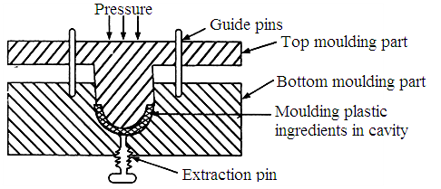

Advantages
- It is used for moulding of glass fibre reinforced plastic.
- Has minimum of internal stresses in the part and less expensive.
- Used to make very heavy parts.
- Switches and sockets are prepared by this method.
- Panels, housings, containers, dishes and automotive parts are prepared.
Limitations
Difficult to mould complex articles with undercuts or small holes.

- Injection moulding (May 14, Nov 18, Sep 20)
Injection moulding is mainly applicable to thermoplastic resins. In this, moulding plastic powder is fed into a heated cylinder. It is the injected at a controlled rate into a tightly-locked mould which is kept cold to allow hot plastic to cure and become rigid.
When the material has been cured sufficiently, half of the mould is opened to allow the injection of finished article without any deformation. Heating is done by oil or electricity.
Advantages
- Mainly used for moulding of thermoplastics.
- High-speed production and low mould cost.
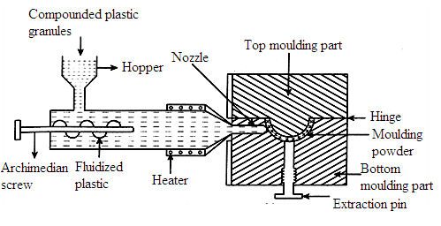
- Very low loss of materials and low finishing cost.
Disadvantage
Since large number of cavities cannot be filled simultaneously, there is limitation of design of articles.
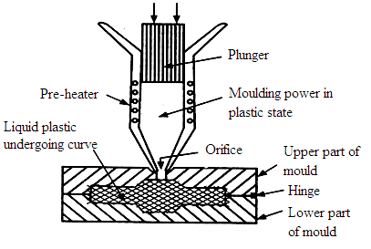
- Transfer moulding (May 19)

Transfer moulding is a method, which uses the principle of injection moulding for thermosetting materials. In this, the moulding powder is placed in a heated chamber, maintained at minimum temperature at which the moulding powder just begins to become plastic. This plastic material is then injected through an orifice into the mould by a plunger, working at a high pressure.
Due to very high temperature developed at orifice, temperature of the material, at the time of ejection from orifice, rises to such an extent that the moulding powder becomes almost liquid. It then flows quickly into the mould which is being heated up to the curing temperature required for setting. The moulded article is then ejected mechanically. Advantages
- Free from flow marks and finishing cost of fabricated article is low.
- Even thick pieces cure almost completely and uniformly.
(iii) Mould cost is less and involves very low abrasive action.

- Extrusion moulding (Jan 14, May 14)
Extrusion moulding is used mainly for continuous moulding of thermoplastic materials into articles of uniform cross-section like tubes, rods, strips and insulated electric cables.
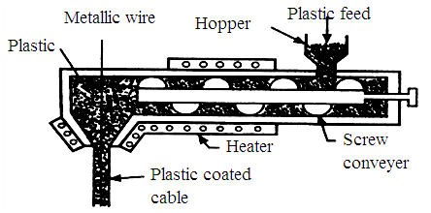

Thermoplastic ingredients are heated to plastic condition and then pushed by means of a screw conveyor into a die, having required outer shape of article to the manufactured.
Here the plastic mass gets cooled, due to atmospheric exposure. A long conveyor continuously carries away the cooled product.
Advantages
- Used for making products such as films, pipes, cables and hoses.
- Used for intermediate operations such as preparation of sheets for vacuum forming,
mixing operations and re-working of waste materials.

